AMERICAN INTERNATIONAL UNIVERSITY

-BANGLADESH

***FACULTY OF SCIENCE & TECHNOLOGY***



# Course Title

### Object Oriented Programming 2

SPRING 2023-2024

Section: P

# Project Proposal:

### Real State Management System

### (CHEMINEE REAL STATE)

#### Submitted to:

TOFAYET SULTAN

Lecturer , Computer Science

#### Submitted By:

|  |  |
| --- | --- |
| **Name** | **Student ID** |
| 1. MD. EMRAN NAZIR EFTY | 22-47802-2 |
| 2. RAKIBUL HASAN | 22-47728-2 |
| 3. NILADRI BISWAS | 22-47834-2 |
| 4. MASHUDH AHMED | 22-47811-2 |

**Submission Date:**

3rd April 2024

**Introduction:** The Real Estate Management System (REMS) is a comprehensive software solution designed to streamline the management of real estate properties, facilitate transactions, and enhance client relationships. This system aims to provide a user-friendly interface for administrators, property managers, buyers and sellers to efficiently handle property listings, client inquiries, and transaction processing.

#### Objectives:

* Develop a centralized platform for managing real estate properties, clients, and transactions.
* Provide role-based access control to accommodate the needs of administrators, property managers, buyers and sellers, .
* Enable real estate agents to list properties, manage client inquiries, and schedule property viewings effectively.
* Allow property managers to oversee property maintenance, handle tenant relations, and enforce lease agreements.
* Facilitate property search, offer submission, and transaction management for buyers/sellers.

**List of users and their activities:**

## Administrator:

* + **User Account Management:** Administrators can create, edit, and deactivate user accounts, assign roles, and manage permissions.
  + **Property Listing Administration:** Administrators can approve property listings, edit listing details, and remove outdated listings.
  + **System Configuration:** Administrators can configure system settings, customize email templates, and manage system preferences.

## Property Managers:

* + **Property Maintenance Tracking:** Managers can track maintenance requests, schedule repairs, and monitor property upkeep.
  + **Tenant Relations Management:** Managers can communicate with tenants, handle lease renewals, and address tenant concerns.
  + **Lease Agreement Enforcement:** Access the menu, view item details, and suggest specials or recommendations.

## Buyer:

* + **Property Search:** Users can search for properties based on criteria such as location, price range, and property type.
  + **Document Upload:** Buyers can upload supporting documents such as pre- approval letters or proof of funds.
  + **Document Access:** Users can access and review contract documents, disclosures, and addendums throughout the transaction process.

## Seller:

* + Sellers can create and manage listings for their properties, including detailed descriptions and photos.
  + **Listing Editing:** Sellers can edit listing details such as price, description, and property features.
  + **Listing Status:** Sellers can set the status of their listings (active, pending, sold) and update it as needed.
  + **Response Options:** Sellers can accept, counter, or decline offers, and communicate their decision to the buyer through the platform.
  + **Document Access:** Users can access and review contract documents, disclosures, and addendum throughout the transaction process.
  + **Task Management:** Users can view and complete tasks required for closing, such as providing escrow deposits or scheduling final walk-thorough.

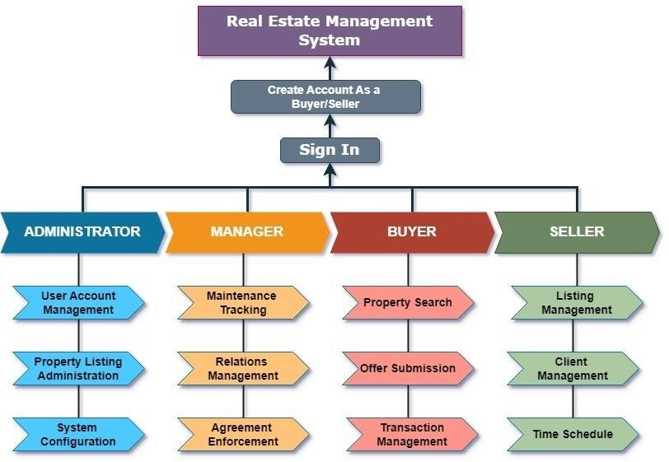

**Conclusion:** The Real Estate Management System (REMS) will revolutionize the way real estate properties are managed, transactions are processed, and client relationships are nurtured. By leveraging cutting-edge technologies and robust features, REMS will empower real estate professionals to streamline their workflows, enhance customer experiences, and drive business growth.